Git Stash

Sometimes a scenario may come where we are working on a current branch and we need to do some other work. Hence need to do a git pull or may be switch to another branch. In that scenario we will need to save our work in progress to some safer place.

This is the time when git stash comes to rescue. It allows us to save our changes temporarily to some safer place which could be later merged to new code.

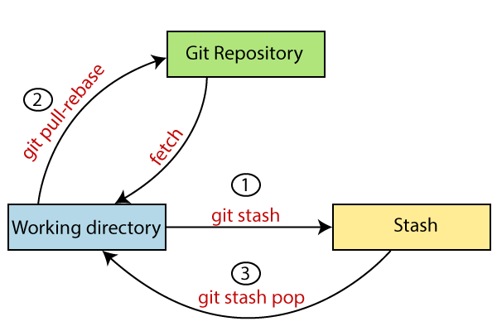

## **Stashing Work**

Con